Test 1:
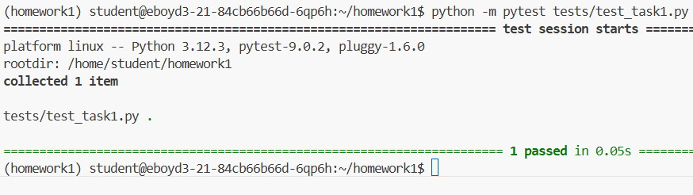
Test 2: 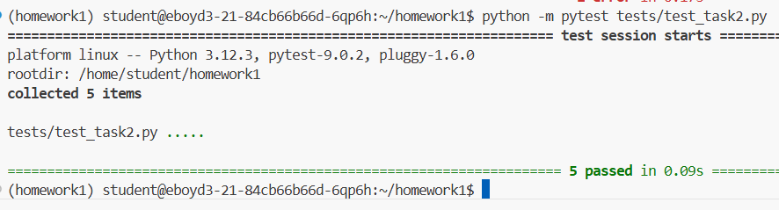
Test 3: 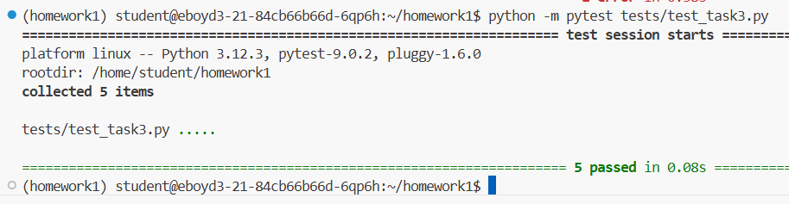
Test 4: 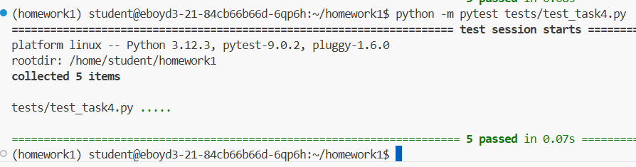Test 5: 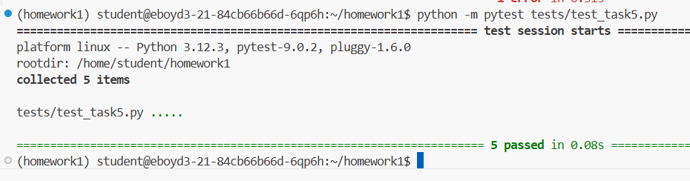
Test 6: 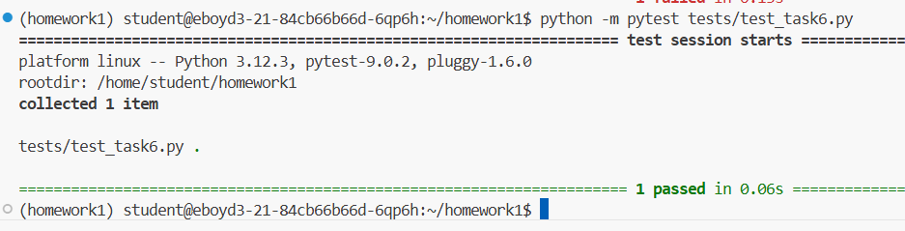Test 7: 